Reminder App

SODV 2101 Term Project

Group 2:

David Hebert

Paul K Kho

 Yadwinder Singh Sidhu

Software Development Diploma Program

Bow Valley College

SODV 2101 Rapid Application Development

Dima Marachi, Instructor

Due: October 5, 2021

Project Description

A reminder app will allow users to keep track of multiple tasks in an organized manner. There are many available on the market for consumers. Our reminder app will be based on Windows Forms. We will use .NET and C# codes. Our project will start with a User Interface in a windows form. This form has buttons the user can interact with. The window will be automatically adjusted to the device’s operating system. For example, it will automatically adapt to the computer screen if the user is using a desktop computer. It will shrink to the limited viewpoints of a mobile phone, laptops, or tablet. This app is designed to run on Windows OS. Future versions would be released on other platforms such as Android, MacOS, GoogleOS, Linux; etc.

Key Features

* User Friendly
* Adjustable Size
* Data loading and retrieval
* Audio and visual notifications

User Interface

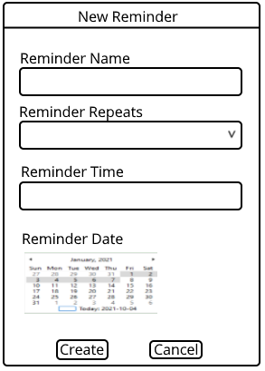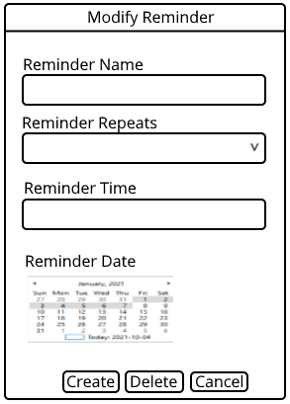

UML Diagram designed by Paul K Kho and David Hebert

References

C# .NET., 2021., Microsoft Documents, Microsoft Visual Studios, Microsoft Corporation.

Group 2., Rapid Web Development., 2021., SODV 2101, Bow Valley College., Calgary, Alberta.

Group2., SODV 2101 Term Project., 2021., Visual Paradigm Community Edition.

SODV 2101 Term Project Proposal Group 2., 2021., Microsoft Word., Microsoft Corporation.

Icons and Images., 2021., Icon8.com.